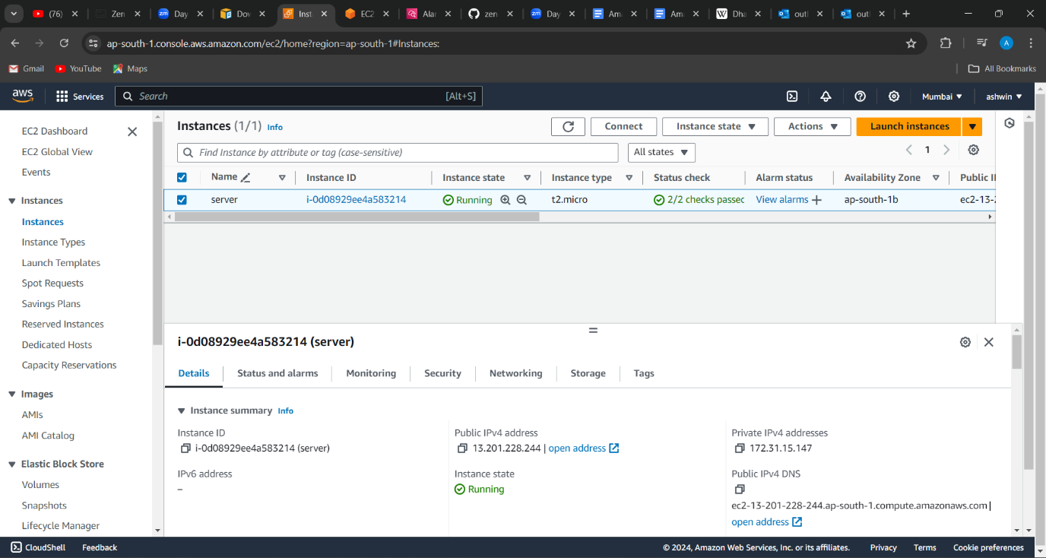

1.created a ec2 instance to monitor cpu utilization

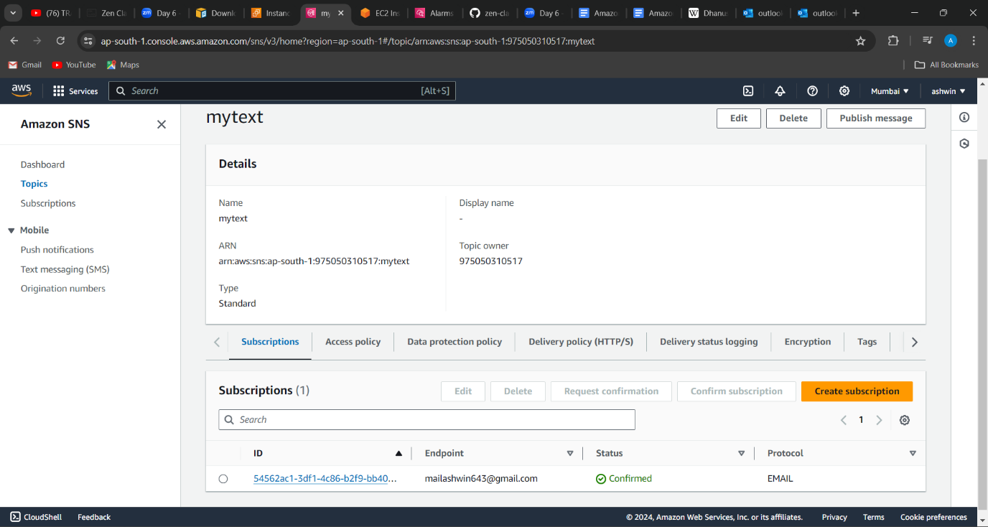

2.created a sns topic and subscribed to mail id to receive alarm message

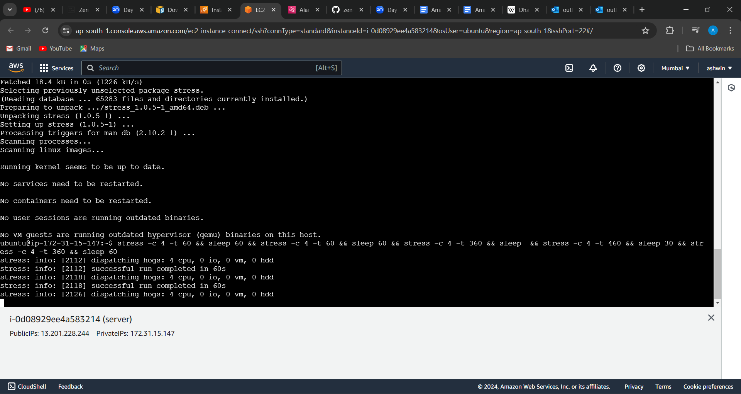

3.created the metrics and given the stress to the instance to get alarm

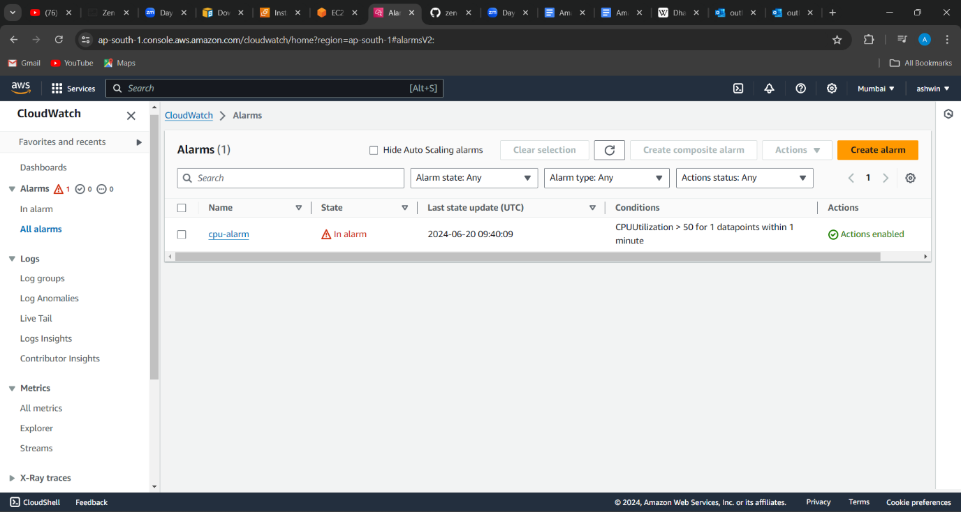

4.created the alarm for cpu utilization and it went from ok state to in alarm state after the stress is given

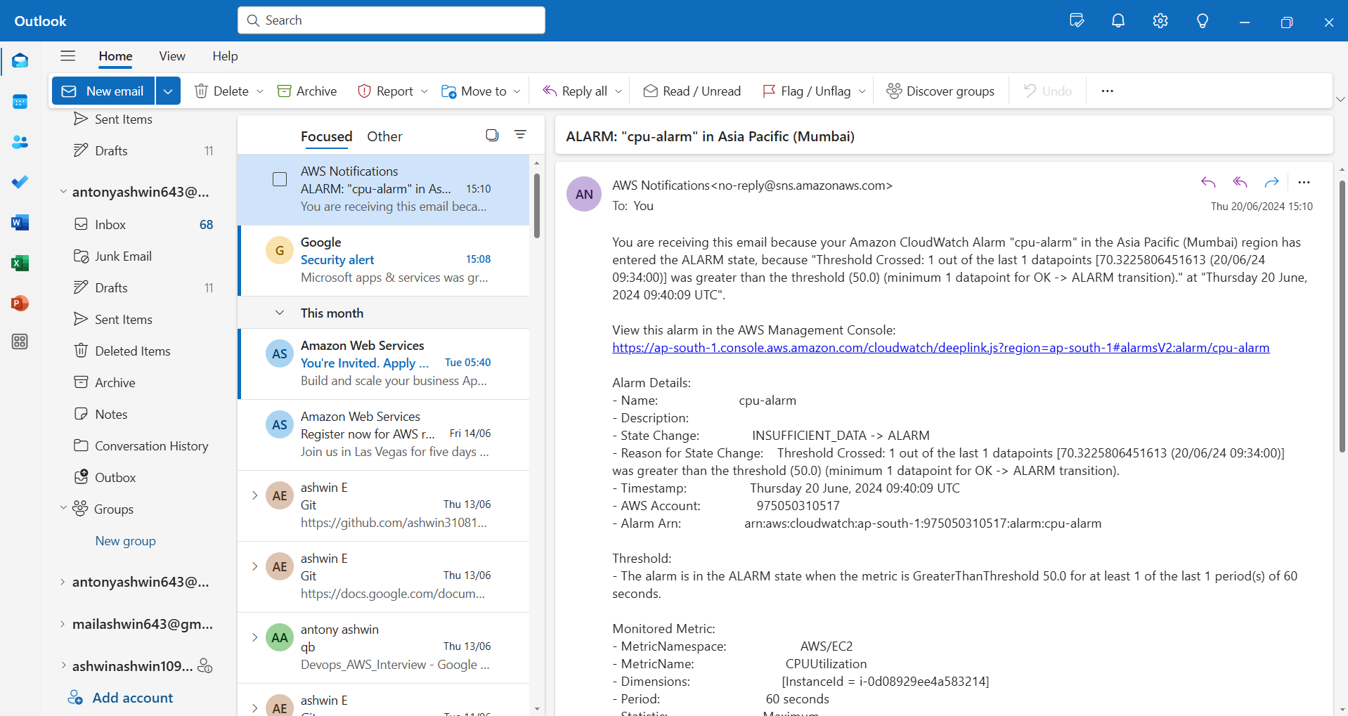

5.when the cpu utilization reached above 50% it gives the mail to configured mail address in sns